Q2: The content of students.txt

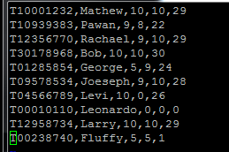

Q5: The cmp and diff commands. I think Bob, George, Joeseph, Levi, and Leonardo all had similar differences, but the fact that Bob was mentioned at the bottom again meant he had the highest mark.

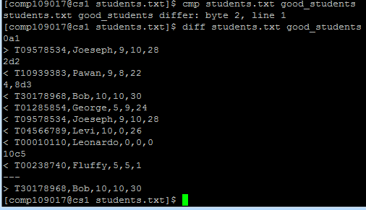

Q1: Code for file Prog1.s

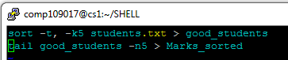

Q2: Code for file Prog2.s

